Analytics Database Manager 3.0

Installation and pre-requirements
The module is distributed as Sitecore Package, which can be installed using the Installation Wizard.
Module works on Sitecore 8.0 or higher.
For Sitecore 8.0 Update 4 or earlier, it is needed to add the MongoDB assembly binding redirect as it is described in the 2nd solution in the following article: https://kb.sitecore.net/articles/920798

User guide
The module can be started from the Launchpad by administrators or users in the “sitecore\ADM admin” role.
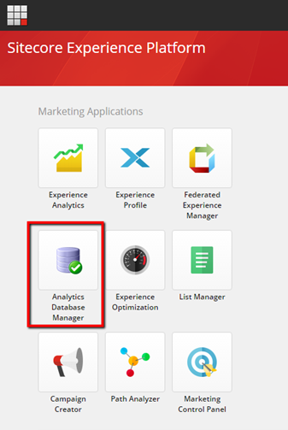

The application has three tabs, each of them is responsible for one operation.
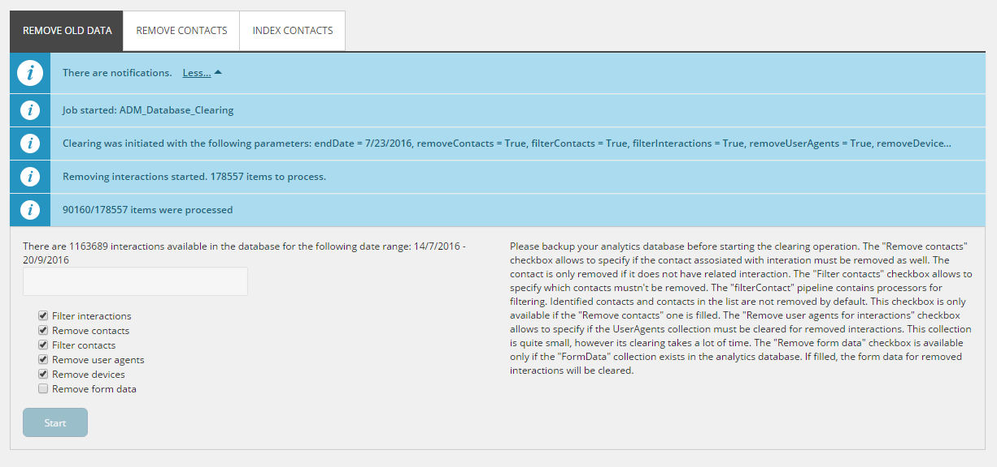
The message bar on each tab allows to monitor the work of the application. The message bar is refreshed automatically each 3 seconds.

Features overview

Remove old data
The operation allows to remove the data from the collection database, which is older than specific date and matches particular conditions. The task clears Interactions, Contacts, ClassificationsMap, Devices, UserAgents and FormData collections.
The removal conditions are controlled by the checkboxes on the application tab and may be the following:
- Filter interaction – if selected, the “filterInteraction” pipeline is executed to determine if the interaction must be removed. By default, the pipeline contains one processor, which checks if there were any form submits during the interaction. Such interactions are not removed.
- Remove contacts – if selected, the contacts, related to the removed interactions are removed as well. The contacts are removed only if they don’t have other related interactions.
- Filter contacts – if selected, “filterContact” pipeline is executed to determine if the contact must be removed. By default, the pipeline has processors, which check if the contact is identified and if the contact is in a list. This option is available only if the “Remove contacts” is checked.
- Remove user agents and Remove devices – if selected, user agents and devices, related to the removed interaction are removed as well. This option is available only if the “Remove contacts” is checked.
Clearing these collections is quite time consuming if the Interactions collection contains many records. Additionally, these collections are usually not very large. Thus, it is recommended to have these options selected only if very big amount of interactions are planned to be removed.
- Remove form data – if selected, the form data related to the removed interaction is removed as well.
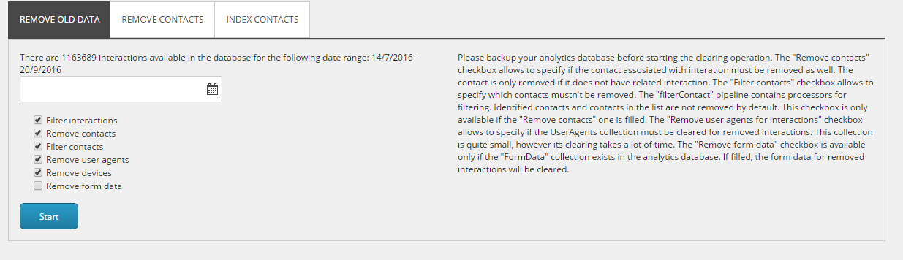

Remove contacts without interactions
The operation removes contacts, which do not have related interactions.
The tab has only one option:
Filter contacts – if selected, “filterContact” pipeline is executed to determine if the contact must be removed. By default, the pipeline has processors if the contacts is identified and if the contact belongs to a list.
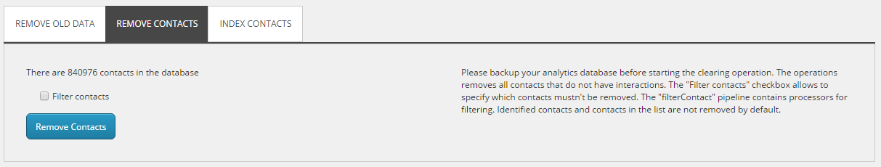

Index all contacts
The operation puts all contacts to the processing pool to be re-indexed. The operation depends on the default processing functionality and may be quite resource consuming in case of large amounts of contacts.
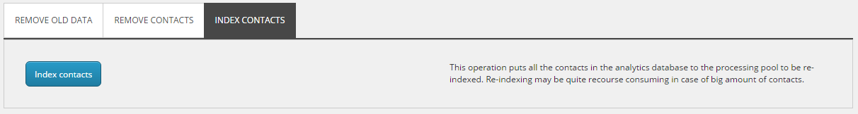

Configuration
All module configuration is located in the following file: App_Config\Include\ADM\Sitecore.AnalyticsDatabaseManager.config

Pipelines
“filterContact” and “filterInteraction” pipelines are located in the ADM group. These pipelines may be extended to implement custom filtering.

Settings
The ADM.UseUpdateMongoDriverSettingsPipeline setting allows to determine if the Sitecore updateMongoDriverSettings pipeline must be called when the mongo driver is initialized. This pipeline allows to add custom mongo authentication. The pipeline was added in Sitecore 8.1, so the ADM.UseUpdateMongoDriverSettingsPipeline setting must be set to false if Sitecore 8.0 is used.
The ADM.CreateMongoIndexes setting allows to specify if temporary mongo indexes can be created for some collections. The indexes are added when UserAgents and Devices collections are cleared to speed up the process.

